**Session 22: DEPLOYING A SPARK APPLICATION**

**Assignment 22.1**

**Problem Statement**

Implement the below blog at your end and send the complete documentation.

[https://docs.google.com/document/d/1csLBlMiEXs_hXWV2Z8VpBlrj_R6RoDQLlZUnA0uBTCk/edit](https://docs.google.com/document/d/1csLBlMiEXs_hXWV2Z8VpBlrj_R6RoDQLlZUnA0uBTCk/edit%20)

**Census data analysis**

You can download the dataset from the below link,

<https://drive.google.com/open?id=0ByJLBTmJojjzWllGZFJFaXFVbU0>

Due to the limitation of **22** elements for a map function, we are taking only **22** columns from the data set. Here is the total dataset description

**State String,DistrictString,PersonsString,Malesint,Females int,Growth_1991_2001 int,Ruralint,Urbanint,Scheduled_Caste_populationint,Percentage_SC_to_totalint,Number_of_householdsint,Household_size_per_household int,Sex_ratio_females_per_1000_males int ,Sex_ratio_0_6_years int,Scheduled_Tribe_populationint,Percentage_to_total_population_STint,Persons_literateint,Males_Literateint,Females_Literateint,Persons_literacy_rateint,Males_Literatacy_Rateint,Females_Literacy_Rateint,Total_Educatedint,Data_without_levelint,Below_Primaryint,Primaryint,Middleint,Matric_Higher_Secondary_Diplomaint,Graduate_and_Above int,X0_4_years int,X5_14_years int,X15_59_years int,X60_years_and_above_Incl_ANS int,Total_workersint,Main_workersint,Marginal_workersint,Non_workers int,SC_1_Name String,SC_1_Population int,SC_2_Name String,SC_2_Population int,SC_3_Name String,SC_3_Population int,Religeon_1_Name String,Religeon_1_Population int,Religeon_2_Name String,Religeon_2_Population int,Religeon_3_Name String,Religeon_3_Population int,ST_1_Name String,ST_1_Population int,ST_2_Name String,ST_2_Population int,ST_3_Name String,ST_3_Population int,Imp_Town_1_Name String,Imp_Town_1_Population int,Imp_Town_2_Name String,Imp_Town_2_Population int,Imp_Town_3_Name String,Imp_Town_3_Population int,Total_Inhabited_Villagesint,Drinking_water_facilitiesint,Safe_Drinking_waterint,Electricity_Power_Supplyint,Electricity_domesticint,Electricity_Agricultureint,Primary_schoolint,Middle_schoolsint,Secondary_Sr_Secondary_schoolsint,Collegeint,Medical_facilityint,Primary_Health_Centreint,Primary_Health_Sub_Centreint,Post_telegraph_and_telephone_facilityint,Bus_servicesint,Paved_approach_roadint,Mud_approach_roadint,Permanent_Houseint,Semi_permanent_Houseint,Temporary_Houseint**

**Here is what we are taking**

**"State" ,"Persons","Males" ,"Females" ,"Growth_1991_2001" ,"Rural" ,"Urban" ,"Scheduled_Caste_population" ,"Percentage_SC_to_total" ,"Number_of_households" ,"Household_size_per_household" ,"Sex_ratio_females_per_1000_males " ,"Sex_ratio_0_6_years" ,"Scheduled_Tribe_population" ,"Percentage_to_total_population_ST" ,"Persons_literate" ,"Males_Literate" ,"Females_Literate" ,"Persons_literacy_rate" ,"Males_Literatacy_Rate" ,"Females_Literacy_Rate" ,"Total_Educated***"*

Creating a RDD,

* ***valcensus_data = sc.textFile("/home/acadgild/hadoop/census.csv").map(x =>x.split(",")).map(x => (x(0),x(2),x(3),x(4),x(5),x(6),x(7),x(8),x(9),x(10),x(11),x(12),x(13),x(14),x(15),x(16),x(17),x(18),x(19),x(20),x(21),x(22)))***
* ***valcensusdata = census_data.toDF ("State","Persons","Males","Females" ,"Growth_1991_2001" ,"Rural" ,"Urban","Scheduled_Caste_population","Percentage_SC_to_total","Number_of_households" ,"Household_size_per_household","Sex_ratio_females_per_1000_males","Sex_ratio_0_6_years" ,"Scheduled_Tribe_population","Percentage_to_total_population_ST","Persons_literate" ,"Males_Literate","Females_Literate","Persons_literacy_rate","Males_Literatacy_Rate" ,"Females_Literacy_Rate" ,"Total_Educated")***
* ***censusdata.createOrReplaceTempView("census")***

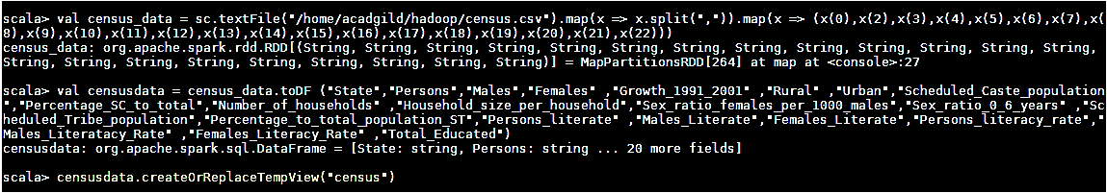

**1. Find out the state wise population and order by state**

***val population = spark.sql("SELECT State,sum(Persons) as total_population from census GROUP BY State ORDER BY total_populationdesc").show***

**Output**

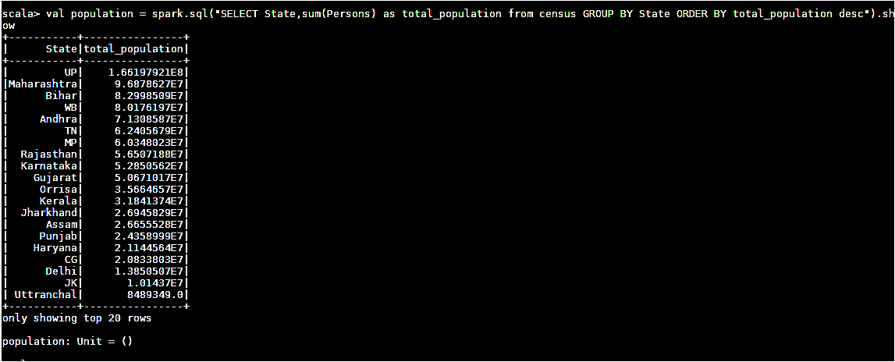

**2. Find out the Growth Rate of Each State Between 1991-2001**

***valgrowth_rate = spark.sql("SELECT State ,avg(Growth_1991_2001) as total_growth from census GROUP BY State ASC").show(50)***

**Output**

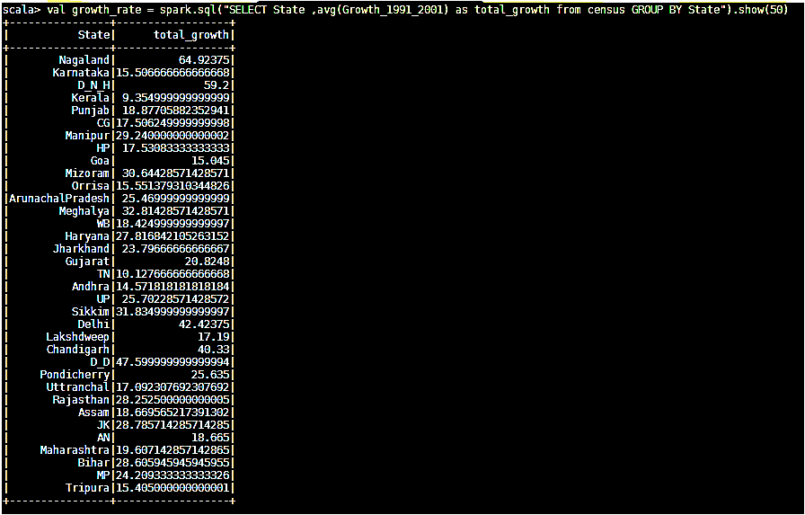

**3. Find the literacy rate of each state**

***val literacy = spark.sql("SELECT State,avg(Persons_literacy_rate) from census GROUP BY State").show***

**Output**

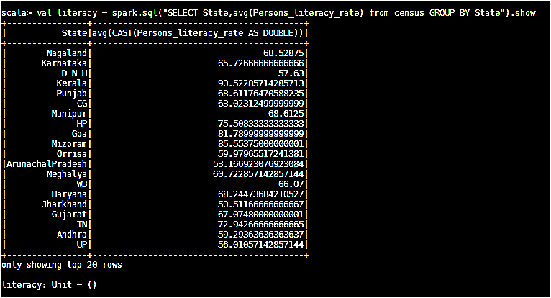

**4. Find out the States with More Female Population**

***valfemale_pop = spark.sql("SELECT State, sum(Males)-sum(Females) from census GROUP BY State").show***

**Output**

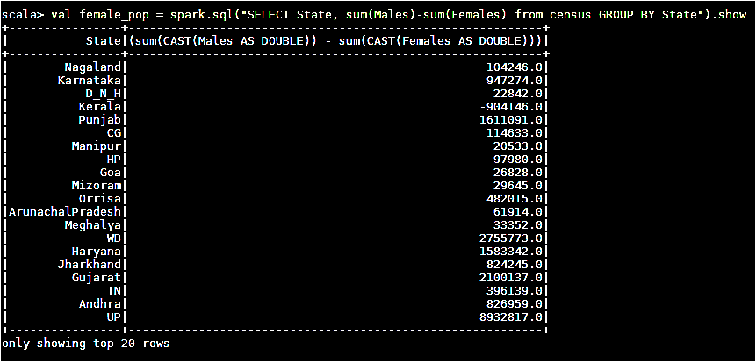

**5. Find out the Percentage of Population in Every State**

***valpercenet_pop = spark.sql("SELECT State, (sum(Persons) * 100.0) / SUM(sum(Persons)) over() as percent_pop_by_state from census GROUP BY State").show(35)***

**Output**

